Pizza Pan/ Cake Pan / Cookie Sheet Immunology

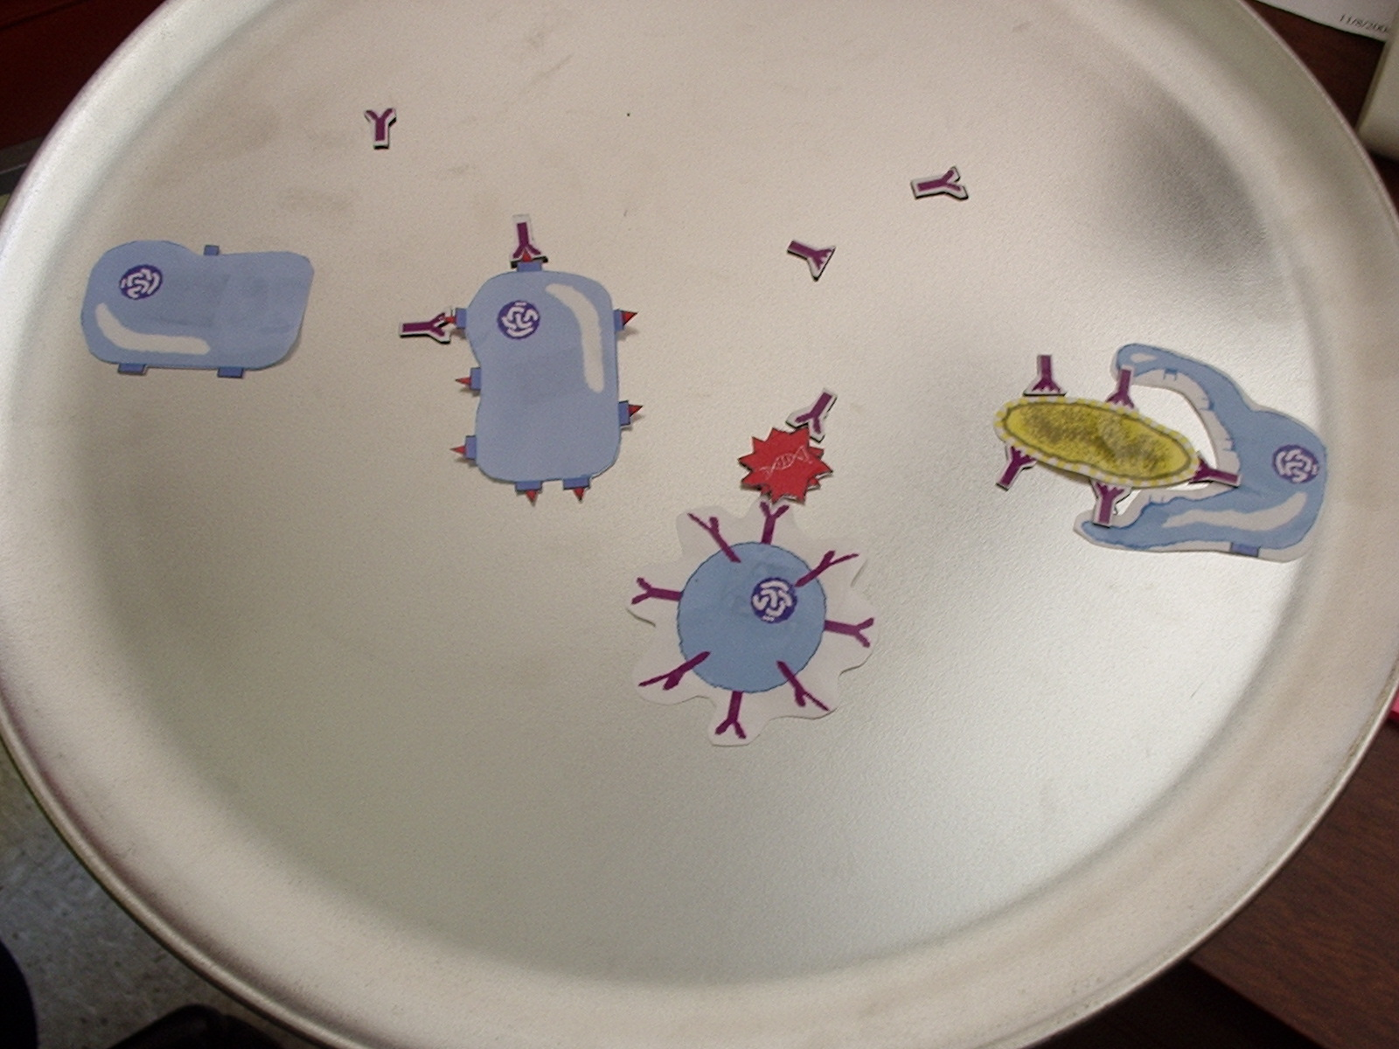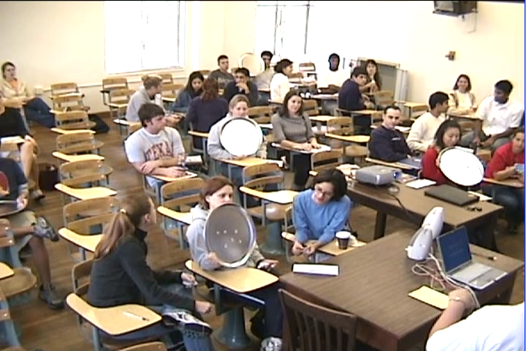

Purpose: This activity makes the process of learning immunology, one of the more complex and daunting lessons of the course, more interactive and clear. It also allows the teacher to address any misconceptions that students may have on the spot.
*Materials: 10 pans (non-aluminum)
10 sets of magnets
To make magnets: 1. Laminate the page containing the cell cartoons. 2. Cut out cell and antibody shapes. 3. Using business card magnets (peel and stick), paste cut-outs on the magnet. 4. Trim excess magnet to fit the cut-out.
Conducting the activity: 1. Assign students to groups of ~ three. 2. In response to teacher questioning, have students display their answers on the pizza pan with the magnets. Students should then hold up the pizza pans so the teacher can quickly assess the general understanding of the class. 3. Teacher then asks a group to come before the class to explain why they displayed a particular magnet or magnets. 4. Steps two and three are repeated with different questions covering basic immunology principles.
*Quantities listed are for a class size of 30.

